**Title: PUBLIC HEALTH AWARENESS**

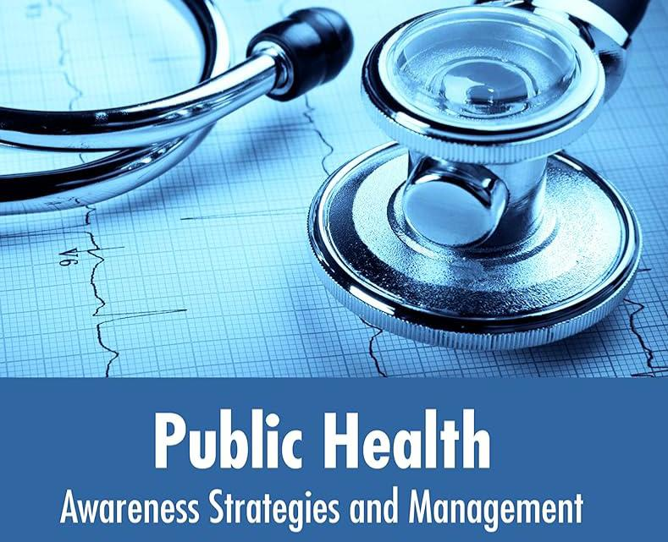

**INTRODUCTION:**

* Incidence of disease is significantly reduced (up to 30%) by Health Awareness. We at Max India Foundation provide health education to underprivileged who have limited information.
* We empower individuals with knowledge to choose healthy habits and make modifications in lifestyle which reduce morbidity.
* We focus on diverse health topics to provide awareness to the communities and increase their levels of Health Literacy.
* Our focus areas are Health & Hygiene, Hand Washing, Menstrual Hygiene, Oral Hygiene, Nutrition, Dengue, Breastfeeding, Anemia, Tobacco Sensitization, Immunization and Cancer.
* This awareness is imparted through tools like Talks, Films, Puppet Shows, Flip Books and Interactive Sessions.

**Objectives:**

* The traditional goal of Public Health is the promotion of population health.
* Besides noting two key ingredients, I will not go very deeply into what is involved in this goal, partly because it should be rather familiar.

1. First, population health in this context is the idea of an aggregate of individual health levels, states, trends etc., and is thus consequentialist in its Second basic construction.
2. The goal is compatible with the idea that some constituents of population health are more important than others—i.e., the aggregate just mentioned need not be a simple sum or statistical average of the individual health

* States in a population, although this may historically have been the most common approach, but something more complicated.

**Data collection:**

* Data collected as part of a public health surveillance system can be used to estimate the magnitude of a problem, identify groups at higher risk of having poorer outcomes, examine relationships between risk factors and outcomes, develop interventions and with continued monitoring assess the effectiveness of the interventions to modify the complications or outcomes.
* The results of analyses from surveillance data can be useful for many purposes including health care and patient advocacy, providing a basis for priority setting and allocation of health care resources, ensuring the availability of better data on population health and supporting medical care quality assurance and quality improvement efforts

**Data analytics:**

Upon successful completion, students will have the knowledge and skills to:

* Define questions of public health significance appropriate to secondary dataset analysis.
* Design an analysis plan

Perform a descriptive analysis.

* Identify and use appropriate statistical analytic approaches and methods.
* Identify limitations of data .
* Communicate findings for public health action.

**Challenges faced:**

In health sector, India has made enormous strides over the past decades. The life expectancy has crossed 67 years, infant and under-five mortality rates are declining as is the rate of disease incidence. Many diseases, such as polio, guinea worm disease, yaws, and tetanus, have been eradicated.

**Conclusion:**

* Public health is the science of protecting and improving the health of people and their communities.
* This work is achieved by promoting healthy lifestyles, researching disease and injury prevention, and detecting, preventing and responding to infectious diseases.